**List of scripts**

*Player*

Playercontroller.cs

Mouselook.cs

WeaponController.cs

*Entities*

EnemyBehaviour.cs

PiggyBehaviour.cs

*Environment*

PickUpScript.cs

InteractScript.cs

ConversationManager.cs

ShopManager.cs

UpgradeManager.cs

FastTravelSaveManager.cs

*Statistics (Don’t destroy on load)*

StatsManager.cs

QuestsManager.cs

PlayerSpawnLocator.cs

InventoryManager.cs

*User Interface*

UIManager.cs

PauseMenuManager.cs

MainMenuManager.cs

LoadController.cs

*Functionality*

PlaySoundAtPoint.cs

DontDestroyAtLoad.cs

**Classes**

Questclass.cs

ItemClass.cs

**Language Structure**

Language: C#

Comment lines before functions.

Brackets on new lines

No hard-coding

Private Component variables start with underscore

Variables start with lower-case letter

Functions start with upper-case letter

Use tabs correctly

Language structure example

RigidBody _rb = GetComponent<RigidBody>();  
public float jumpForce;

//Jump in the air  
public void Jump()  
{  
 _rb.AddForce(new Vector3(0, jumpForce, 0);

}

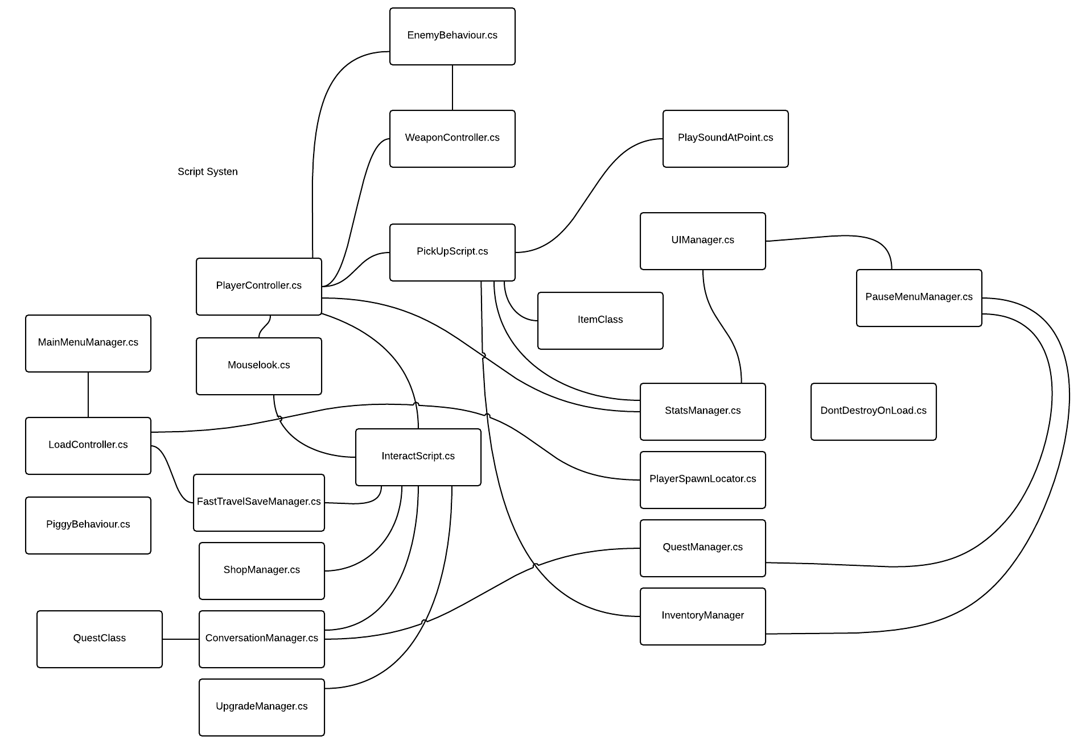spinneweb